EXPERIMENT NO. 29

Creating a Feature Branch and Merging It Using a Pull Request

Aim
To create a new Git branch, implement a simple login function, push the changes to GitHub, and merge the feature branch into the main branch using a Pull Request.

Software Requirements
- Windows 10/11 (or Linux/macOS)
- Git
- GitHub Account
- Python 3.x
- Visual Studio Code (or any code editor)
- Web Browser
- Internet Connection

Theory
Git branches allow developers to work on new features independently without affecting the main project. After completing the feature, the changes are pushed to GitHub and a Pull Request (PR) is created for review. Once approved, the feature branch is merged into the main branch, making the new functionality part of the project.

Procedure
Step 1: Clone the Repository
Open Git Bash or Terminal.
git clone https://github.com/YourUsername/RepositoryName.git

Move to the project folder.
cd RepositoryName
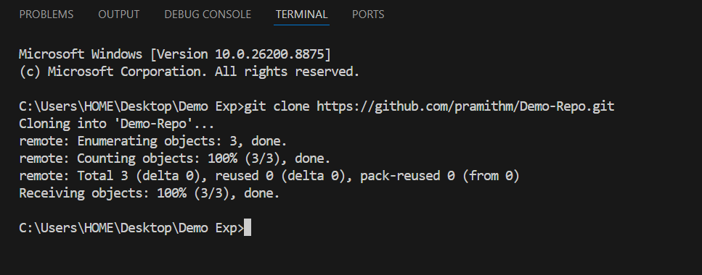
Step 2: Create a New Branch
Create and switch to the feature-login branch.
git checkout -b feature-login

Verify the current branch.
git branch
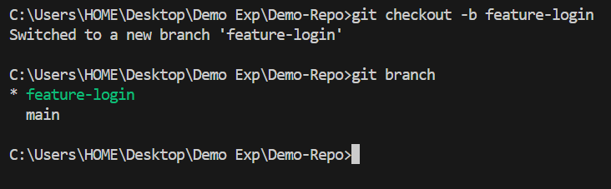

Step 3: Create the login.py File
Create a file named login.py. Add the following code.
def login(username, password):
if username == "admin" and password == "admin123":
return "Login Successful"
return "Invalid Username or Password"

print(login("admin", "admin123"))

Save the file.
Step 4: Check the Repository Status
git status

Step 5: Stage the Changes
git add login.py

Step 6: Commit the Changes
git commit -m "Added login functionality"

Step 7: Push the Branch to GitHub
git push origin feature-login

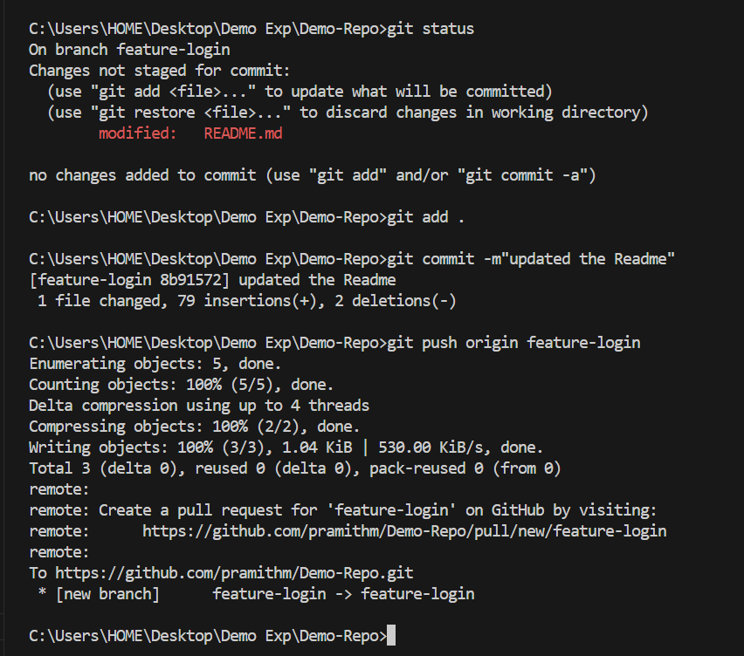

Step 8: Create a Pull Request
- Open the repository on GitHub.
- Click Compare & Pull Request.
- Select Base branch: main, Compare branch: feature-login.
- Enter a title and description.
- Click Create Pull Request.
Step 9: Merge the Pull Request
- Review the Pull Request.
- Click Merge Pull Request.
- Click Confirm Merge.
- Delete the feature-login branch (optional).

Screenshots
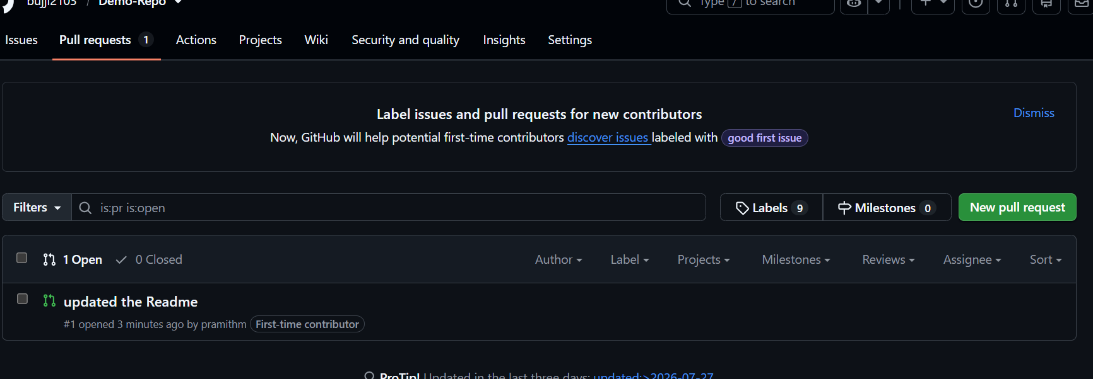

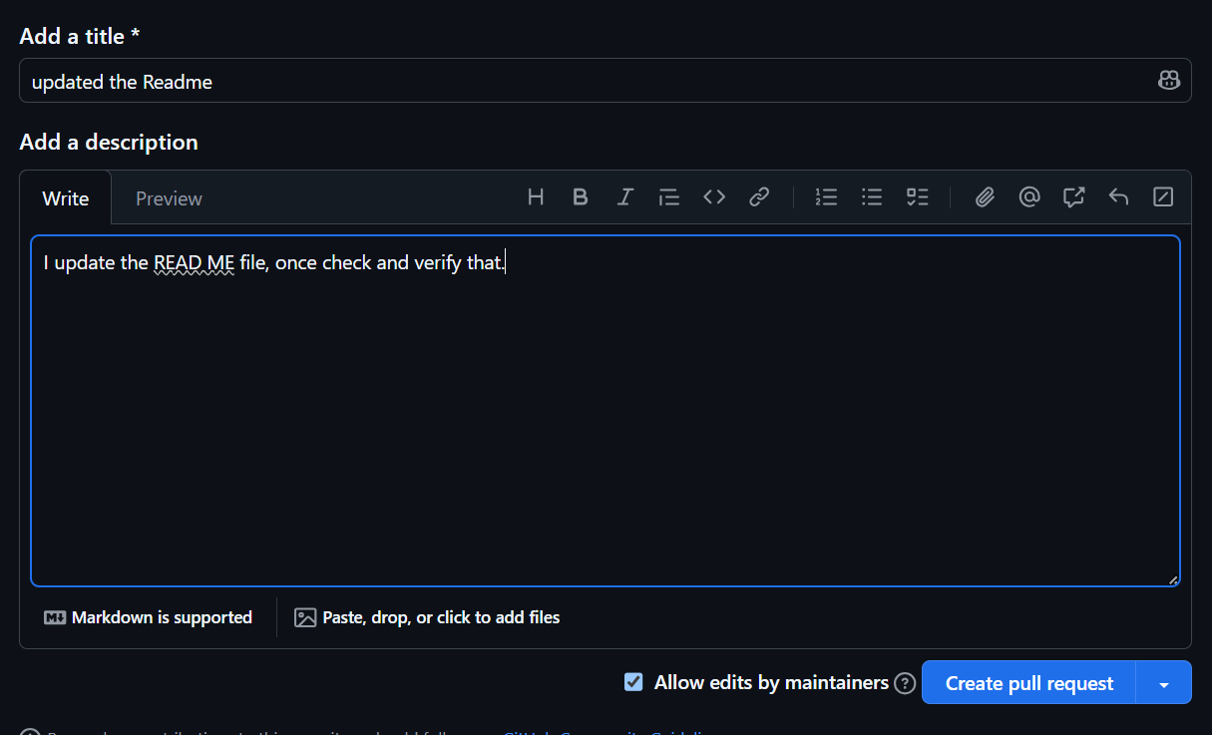

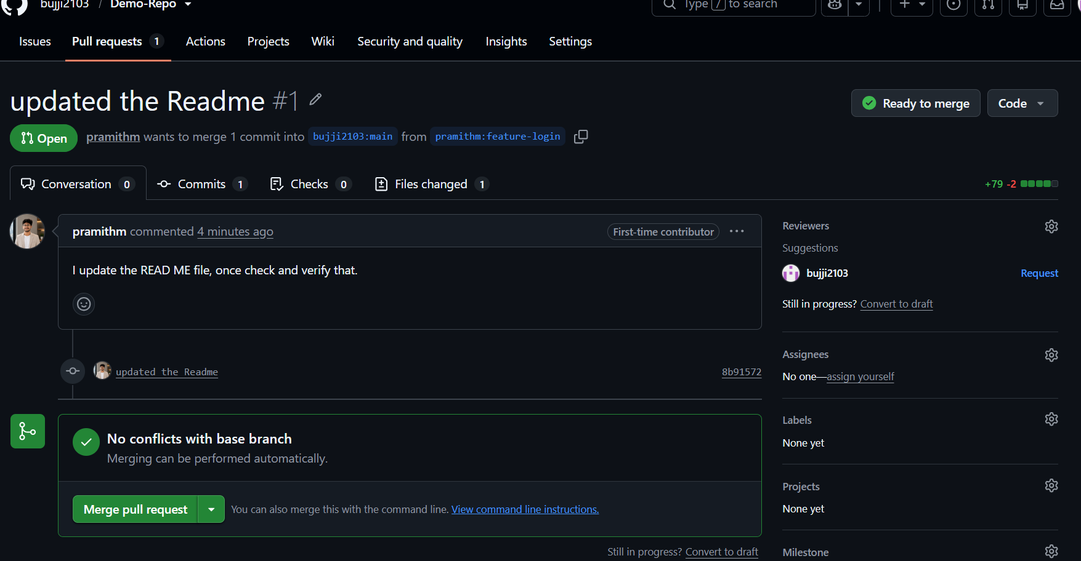

Observation
- The feature-login branch was created successfully.
- The login.py file was added.
- The changes were committed and pushed to GitHub.
- A Pull Request was created successfully.
- The Pull Request was merged into the main branch.

Result
A new feature branch named feature-login was successfully created. The login functionality was implemented in login.py, committed and pushed to GitHub. The changes were merged into the main branch using a Pull Request successfully.

